**FDIC**

The **Federal Deposit Insurance Corporation (FDIC)** is an independent agency of the United States government that provides deposit insurance to depositors in U.S. commercial banks and savings institutions. Here are some key points about the FDIC:

1. **Establishment**: The FDIC was created by the Banking Act of 1933 in response to the thousands of bank failures that occurred in the 1920s and early 1930s. It began operations on January 1, 1934.
2. **Insurance Coverage**: The FDIC insures deposits at member banks up to a standard insurance amount of $250,000 per depositor, per insured bank, for each account ownership category. This insurance protects depositors against the loss of their insured deposits if an FDIC-insured bank or savings institution fails.
3. **Regulation and Supervision**: The FDIC also has regulatory and supervisory responsibilities. It examines and supervises more than 5,000 banks and savings institutions for operational safety and soundness and consumer protection.
4. **Bank Failures and Resolutions**: In the event of a bank failure, the FDIC acts as the receiver. It manages the resolution of failed banks, including the payment of insured deposits and the sale of the institution's assets.
5. **Mission**: The FDIC's mission is to maintain stability and public confidence in the nation's financial system by insuring deposits, examining and supervising financial institutions, and managing receiverships.

|  |  |
| --- | --- |
| Category |  |
| Total Personal Loans | $1.04 trillion |
| Average Loan Amount | $8,402 per loan |
| Interest Rate | Average of 9.58% for new 24-month personal loans |
| Deliquency Rate | 2.37% of all personal loans |
| Purpose of Loans | 33% debt consolidation, 21% for home improvements, 20% major purpose, 11% for medical purpose, 15% for other uses |
| Loan Growth (YoY) | 6.3% Increase from the previous year |

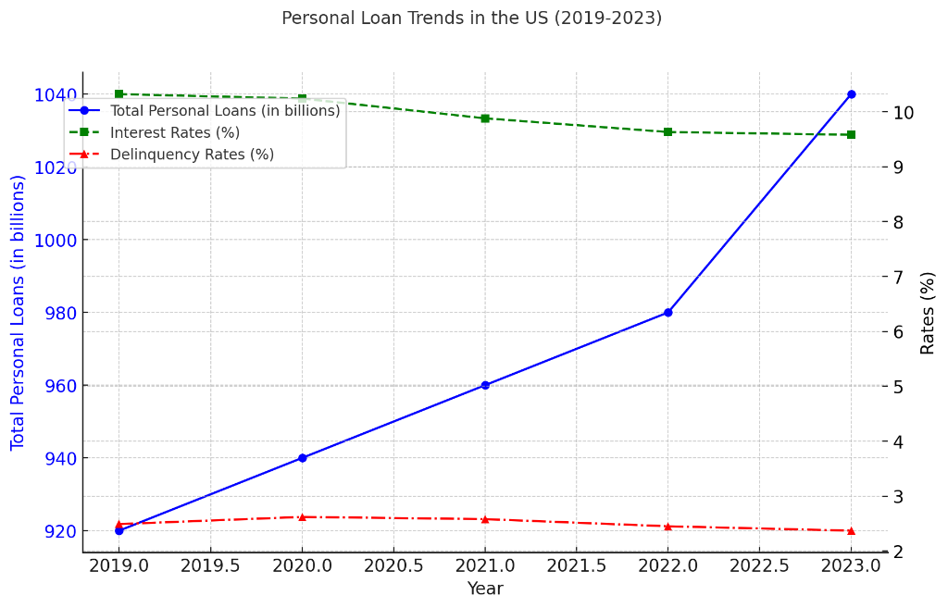

**OCC**

The Office of the Comptroller of the Currency (OCC) is an independent bureau within the United States Department of the Treasury. It was established by the National Currency Act of 1863 and is responsible for regulating and supervising all national banks and federal savings associations, as well as federal branches and agencies of foreign banks.

**Responsibilities and Functions of the OCC:**

1. **Chartering**:
   * The OCC grants charters for new national banks and federal savings associations.
2. **Regulation and Supervision**:
   * The OCC establishes regulations, conducts regular examinations, and ensures that the institutions it oversees operate safely and soundly, provide fair access to financial services, treat customers fairly, and comply with applicable laws and regulations.
3. **Consumer Protection**:
   * The OCC enforces laws and regulations that protect consumers in their financial transactions. This includes overseeing compliance with the Community Reinvestment Act (CRA), which encourages financial institutions to help meet the credit needs of the communities in which they operate.
4. **Enforcement Actions**:
   * When banks or savings associations fail to comply with laws or regulations, the OCC has the authority to take enforcement actions, such as imposing fines or restrictions on the activities of these institutions.
5. **Risk Management**:
   * The OCC assesses and manages various risks, including credit, market, liquidity, operational, compliance, and reputational risks within the banking system.
6. **Policy Development**:
   * The OCC develops policies and procedures to address emerging risks and ensure the stability and integrity of the national banking system.

**SOME MORE UPDATES**

1. **Trading Revenue**: U.S. commercial banks and savings associations reported a cumulative trading revenue of $13.2 billion in Q3 2023.
2. **Derivatives Notional Amount**: The total notional amount of derivatives held by these institutions was $188.8 trillion.
3. **Credit Exposure**: The net current credit exposure (NCCE) decreased by 2.7% to $470.2 billion from the previous quarter.
4. **Interest Rate Contracts**: These contracts represented the majority of derivative activity, accounting for 79.2% of the total notional amount.
5. For Q4 2023, the cumulative trading revenue was reported at $11.6 billion.

**Federal Reserve System**

The Federal Reserve System, often referred to as "the Fed," is the central banking system of the United States. It was established by the Federal Reserve Act, signed into law by President Woodrow Wilson on December 23, 1913, in response to a series of financial panics that highlighted the need for central control of the monetary system to alleviate financial crises.

**Key Functions of the Federal Reserve System**

1. **Monetary Policy**:
   * The Fed conducts monetary policy to manage inflation, maximize employment, and stabilize interest rates.
   * It uses tools such as open market operations, the discount rate, and reserve requirements to influence the economy.
2. **Supervision and Regulation**:
   * The Fed supervises and regulates banks to ensure the safety and soundness of the nation's banking and financial system and to protect consumers' credit rights.
3. **Financial Services**:
   * The Fed provides various financial services to depository institutions, the U.S. government, and foreign official institutions, including payment services and currency distribution.
4. **Financial Stability**:
   * The Fed monitors and analyses the stability of the financial system and provides emergency lending to institutions during crises.

**Structure of the Federal Reserve System**

1. Board of Governors:
2. Federal Reserve Banks:
3. Federal Open Market Committee (FOMC):
4. Member Banks:

|  |  |
| --- | --- |
| **Year** | **Federal Funds Rate** |
| **2019** | 2.50% |
| **2020** | 0.25% |
| **2021** | 0.25% |
| **2022** | 1.75% |
| **2023** | 5.25% |